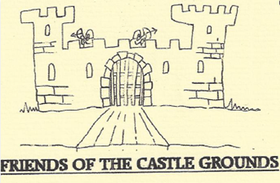

Membership No: ........................

Friends of the Castle Grounds is a small group of people who really value this Scheduled Ancient Monument in the heart of our lovely village. We have a Committee that meets regularly to plan our activities. Our objective is to improve the appearance and use of the Grounds for the benefit of the Parish in conjunction with English Heritage and the Parish Council. Although we work hard to keep the whole site looking clean and tidy we are currently working to improve the banks and establish wild flowers which we feel will enhance the beauty of the grounds. This involves many hours labour and considerable expense, some members have contributed their time working and fundraising to help us achieve this.
We would welcome like minded people who enjoy the site to become a ‘Friend’. A minimum donation of £5 Annual Membership would ensure you have a role in maintaining and improving this precious site.

Membership Secretary: Jean Welford, Aberford, Hopcraft Lane, Deddington
OX15 0TD Tel: 01869 338539
(Cheques made payable to: Friends of the Castle Grounds)
-----------------------------------------------------------------------------------------------------------

FoCG Membership Number: ....................
Name: ......................................................................................................................................................

Address: ................................................................................................................................................

Telephone Number: ..........................................................................................................................

Email Address:......................................................................................................................................

